Student Lab Manual - Working with Linux Containers using Docker

Lab Objective
Learn how to pull a Linux image, start a Linux container, work with the operating system, manage files, users, networking and packages.

Exercise 1 - Pull Ubuntu Image
docker pull ubuntu:24.04
docker images
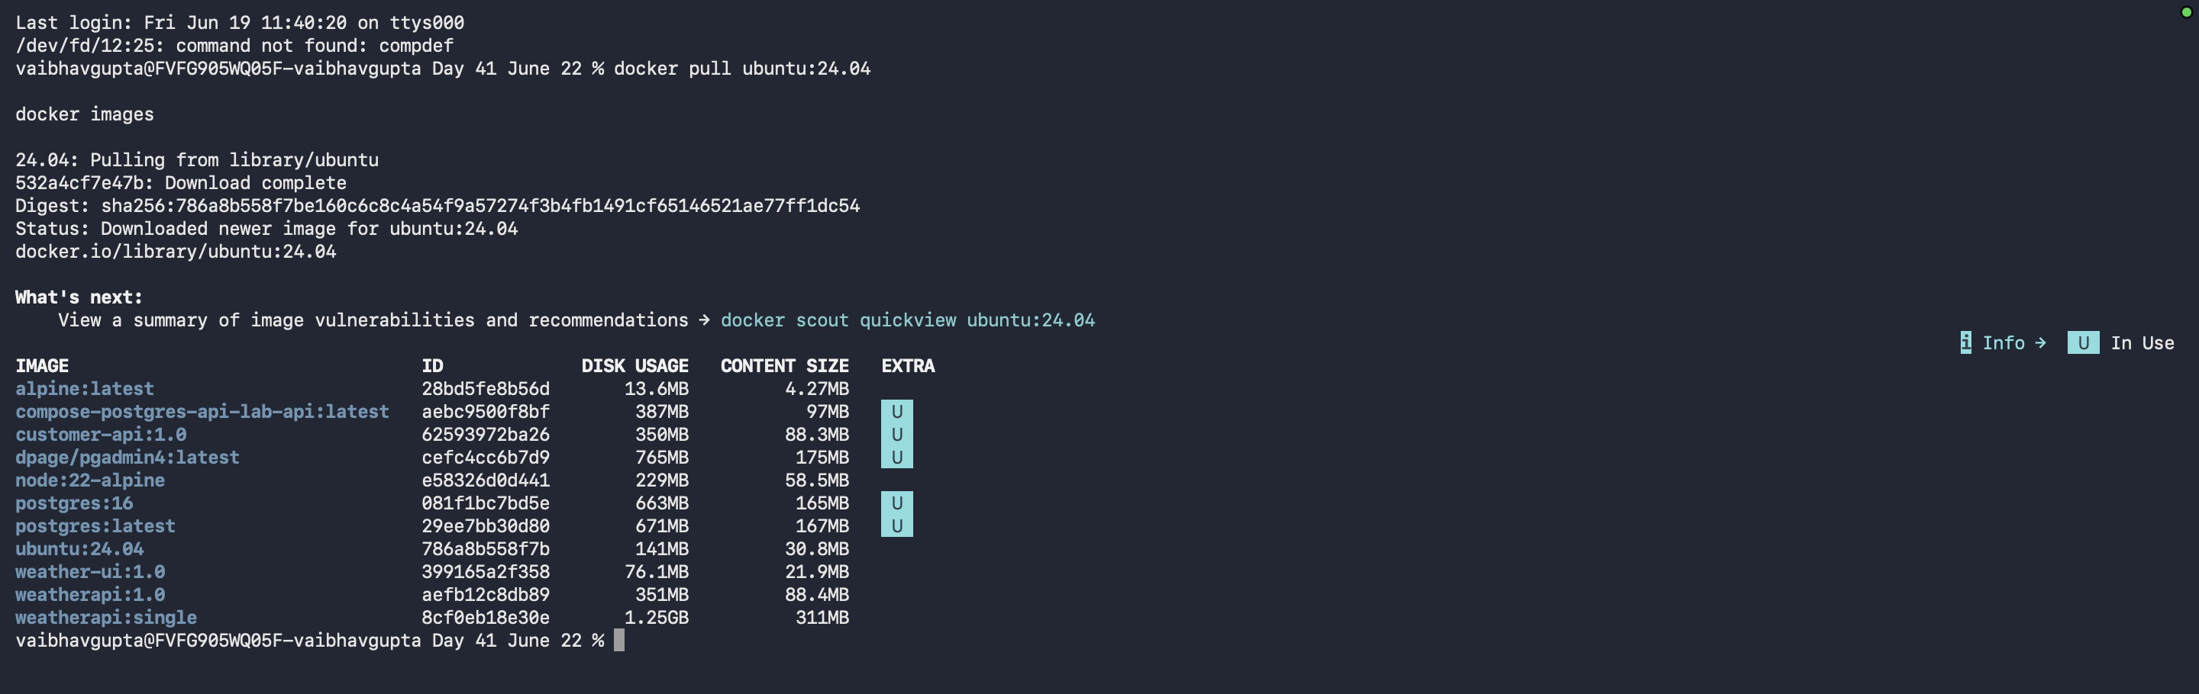

Exercise 2 - Start Ubuntu Container
docker run -it ubuntu:24.04 bash

Exercise 3 - Linux Navigation
pwd
ls
ls -la
cd /etc
ls
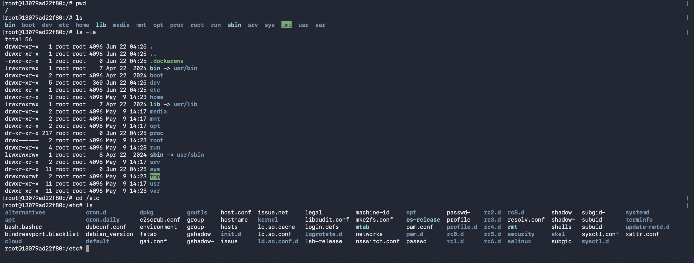

Exercise 4 - Operating System Information
cat /etc/os-release
whoami
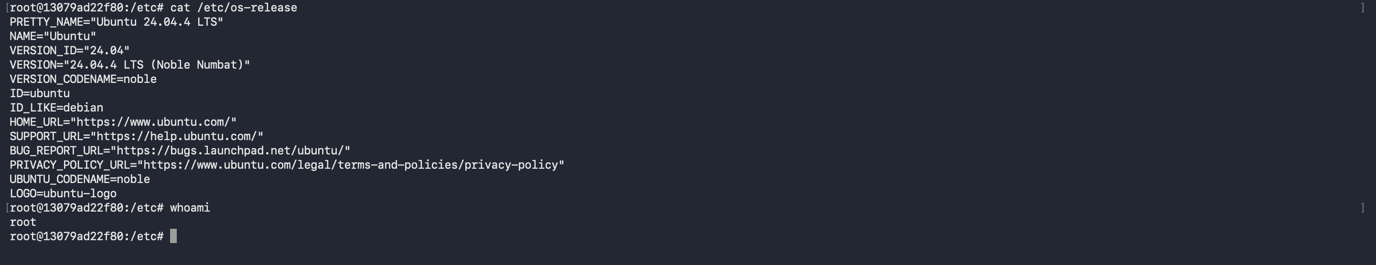

Exercise 5 - File Management
touch notes.txt
echo "Hello Docker" > notes.txt
cat notes.txt
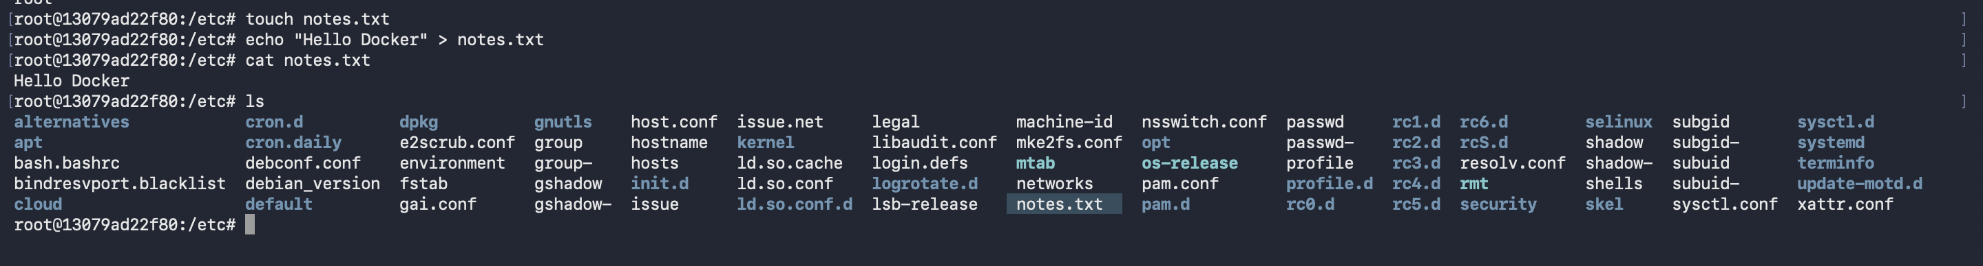

Exercise 6 - Directories
mkdir training
cd training
touch test.txt
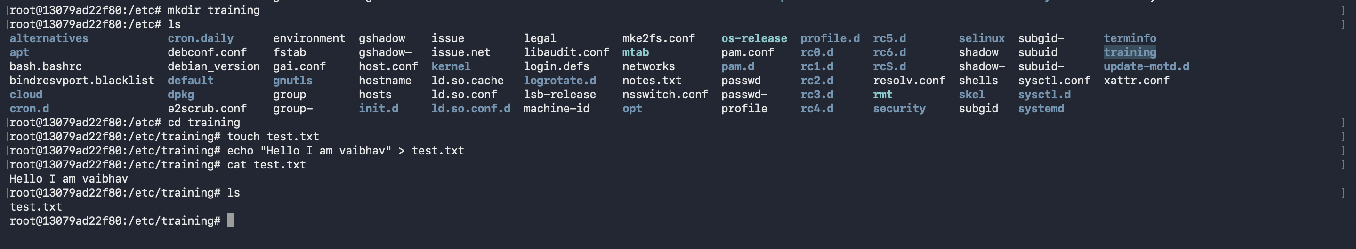

Exercise 7 - Processes
ps -ef

Exercise 8 - Install Software
apt update
apt install curl -y
curl –version
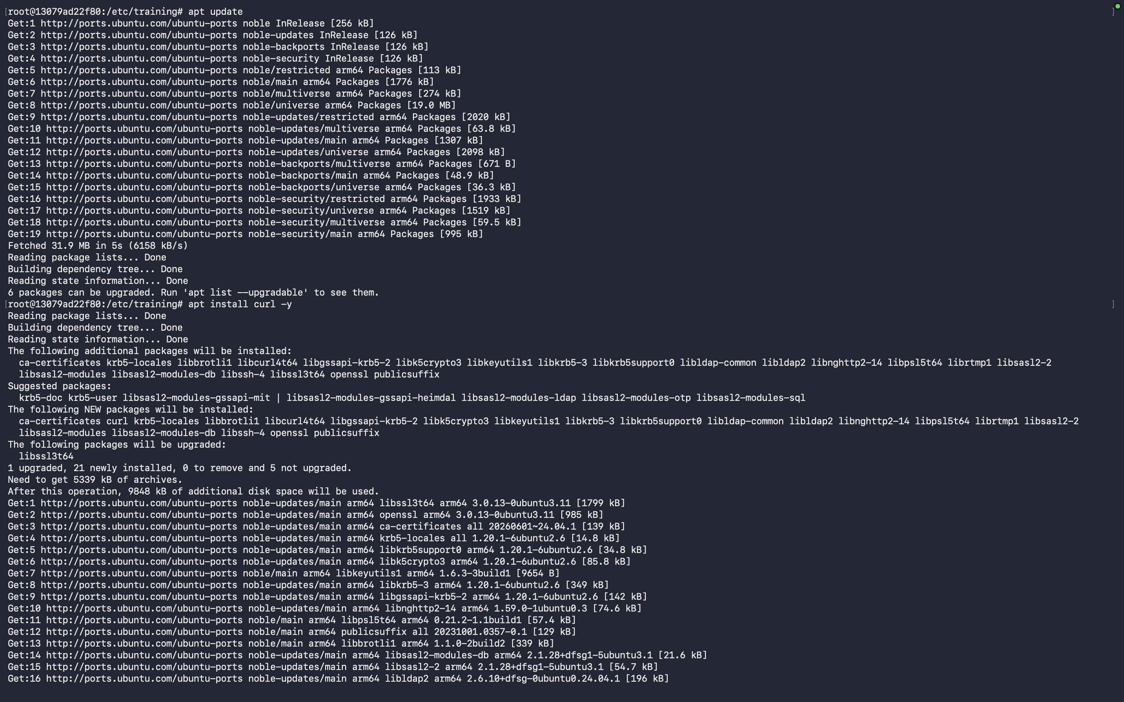
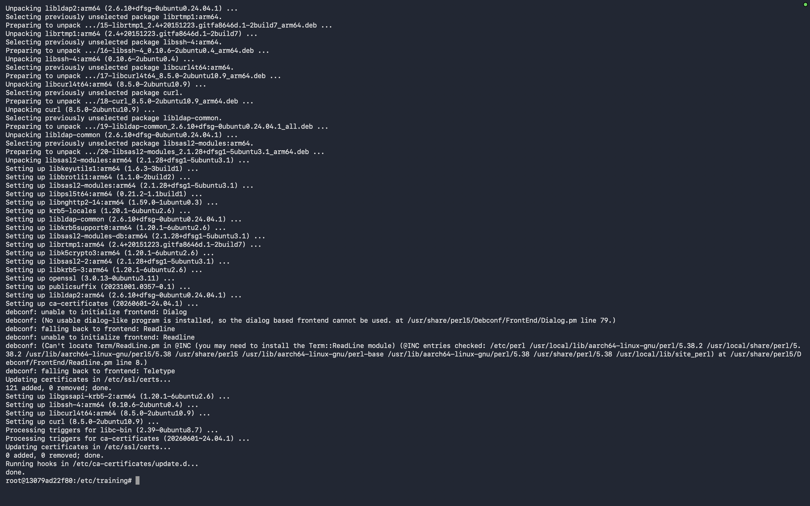
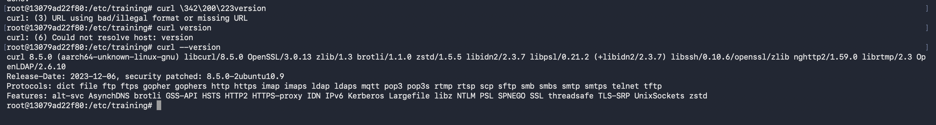

Exercise 9 - Networking
hostname
hostname -I
apt install iputils-ping -y
ping google.com
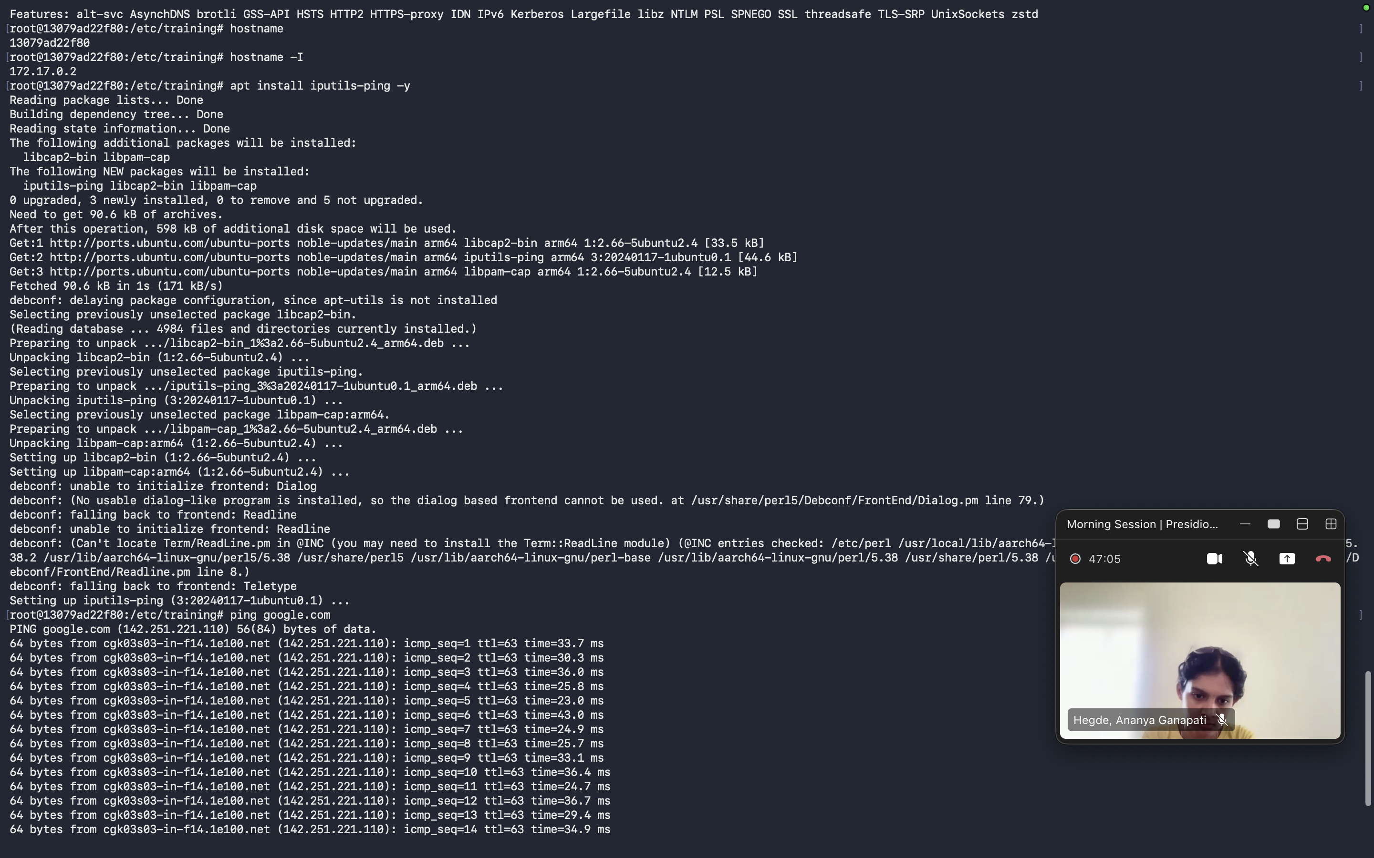
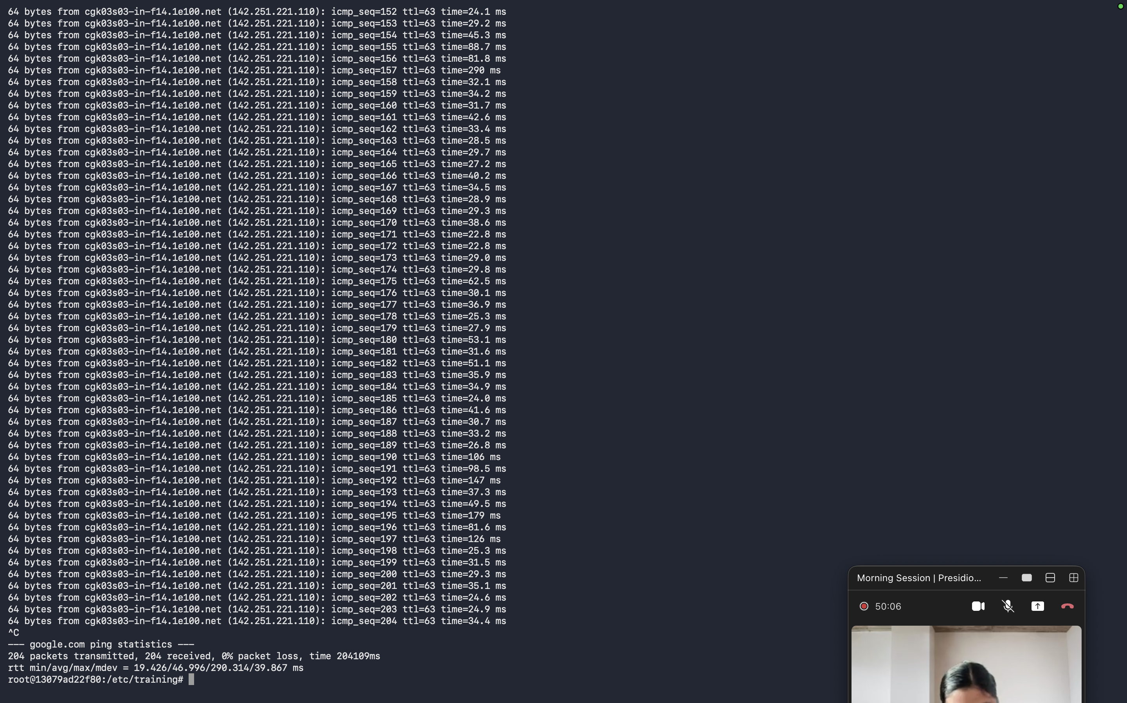

Exercise 10 - Users
useradd student
grep student /etc/passwd

Exercise 11 - Permissions
touch secret.txt
chmod 777 secret.txt
ls -l

Exercise 12 - Environment Variables
export COMPANY=Training
echo $COMPANY
env
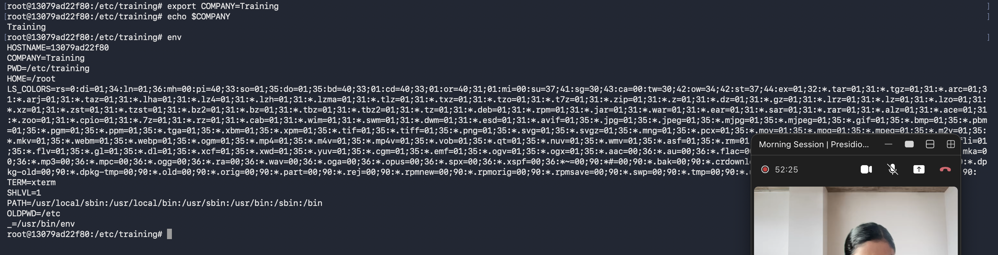

Exercise 13 - Exit and Reconnect
exit
docker ps -a
docker start <container-id>
docker attach <container-id>
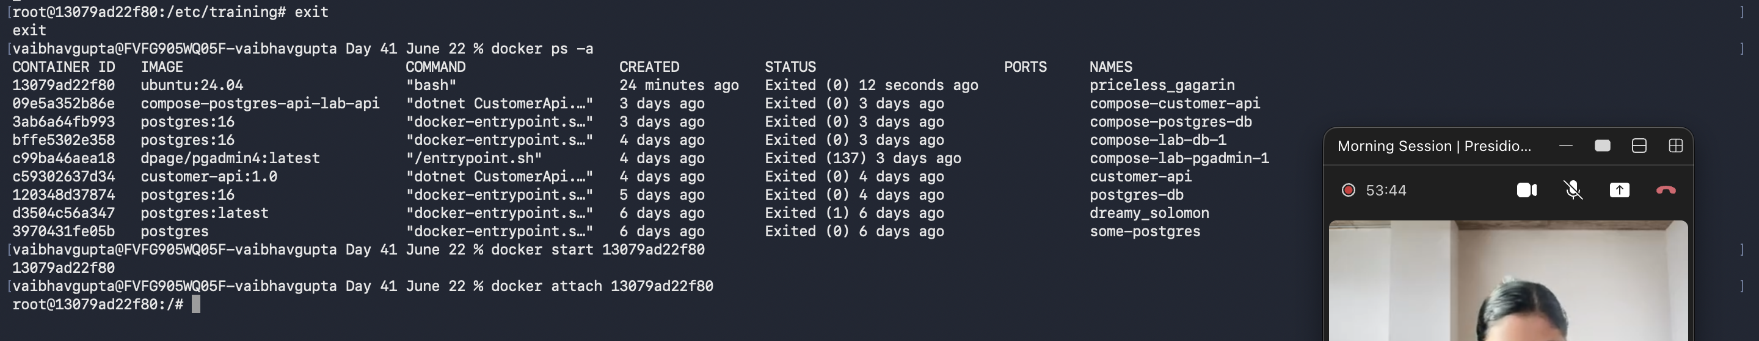

Exercise 14 - Alpine Linux
docker pull alpine
docker run -it alpine sh
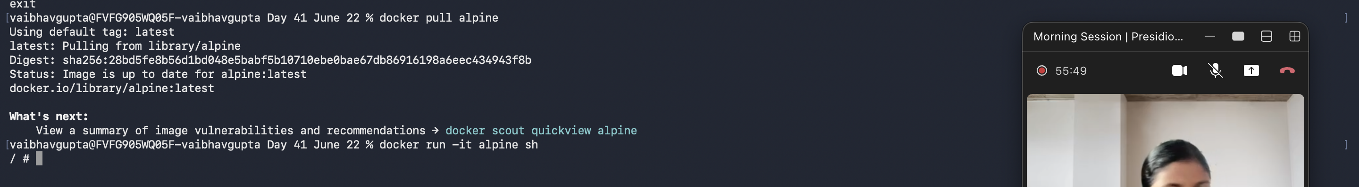

Knowledge Check
What is an image? What is a container? What command creates a file? What command installs software?

